Training and Outreach Officer

Application Pack

  - Deadline: November 10th, 2016

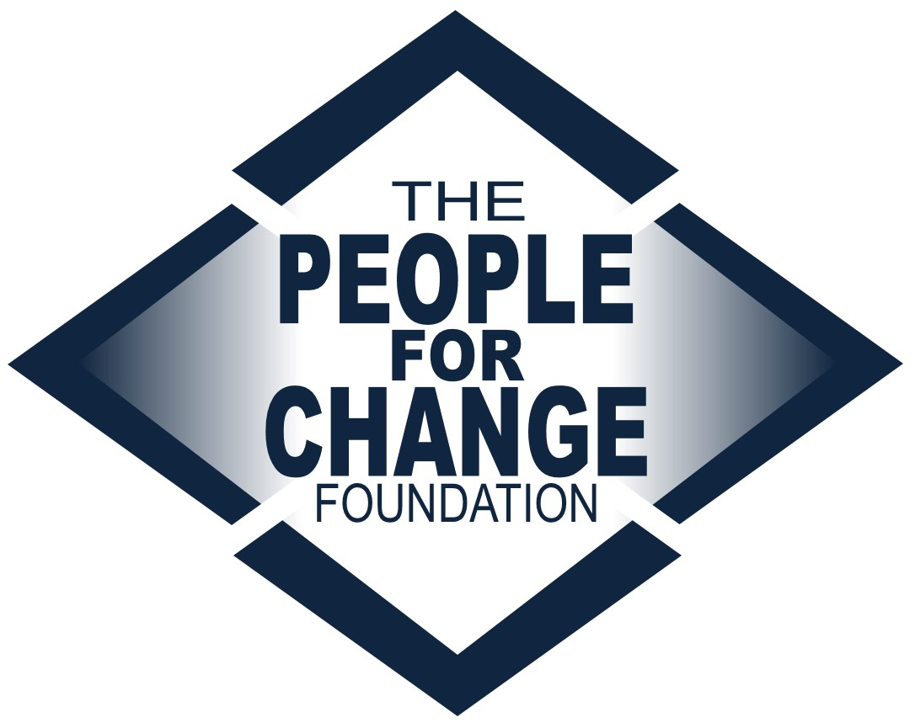

www.pfcmalta.org

About the People for Change Foundation

The People for Change Foundation (PfC) is a Malta-based human rights think tank with a local, European and global scope. Set up in 2007, PfC provides evidence-based, independent, practical and creative ideas on the promotion, respect and protection of human rights in Malta and across the European Union. Our high quality and respected work involves inter-disciplinary analysis, debate and action on a variety of contemporary human rights issues. PfC was set up with the express aim of contributing to a multilateral process, conducting research in an area of direct relevance to the quality of life and life outcomes of the communities we work with and for; to address international and national legal obligations and development, human rights concerns, and long-term sustainable social cohesion. It also aims to bring together different actors, methods and approaches – activism and research, policy and practice.

The Foundation became Malta’s representative member of the European Network Against Racism, and a member of the European Migration Forum and the EASO Consultative Forum. It has run projects funded by a number of public and private funders, including the European Commission. We boast a wide disciplinary array of project partners, including the Malta Ministry of Justice, the National Commission for the Promotion of Equality, the International Organization for Migration, the Universities of Malta, Coventry and Middlesex, UNHCR, IOM, as well as NGOs, think tanks and other organisations from across the European Union.
This recruitment takes place at a very exciting time for the organisation as we continue to grow both in terms of the work we undertake as well as the team and network we work with in doing so.

For more information about the organisation and its work visit www.pfcmalta.org

About the Position

- Job Title | Training and Outreach Officer
- The Post Holder | You will be an exceptional trainer and networker, passionate about human rights and integration, and dedicated to raising awareness and changing behaviour. You will be exceptional at explaining complex issues to diverse audiences in clear ways.  You will be organized yet can work proactively and creatively under pressure. You can demonstrate a fluent understanding of human rights and policy in Malta and across the European Union particularly as it relates to discrimination and hate crime.  You will be an outgoing, confident individual who is able to represent and promote the organisation’s mission and objectives. You will be willing to take initiative and work in a team.
- Educational Background | Bachelors degree required. A degree in teaching or other qualifications relating to education and training preferred. Degrees should be in a related field (law, social science, political science etc).
- Professional Background | Minimum 2-4 years of work experience in the field of human rights or related field required, particularly working in a small NGO or within the public sector. Voluntary work or internships will be considered, so long as independent work can be verified. Experience of multiple commissions from the same institution will be considered an asset.
Skills | Whilst seeking a candidate with a particular educational and professional background, we are keen to work with an individual who exhibits a number of important skills:  - Communicative - able to communicate with a range of stakeholders at all levels, and talented at communicating internally within the organization  - Creative – able to identify and implement creative ways that PfC can expand its reach  - Strong team player – keen to professionally engage and work with other team members  - Innovative and entrepreneurial – able to seek out and identify partnership and project opportunities, able to take ownership of projects  - Problem solver – able to think outside the box and to work proactively  Attentive to detail – able to engage with both policy and research written work, and critically review and improve the quality of outputs
- Languages | Professional level of English, both written and spoken. Knowledge of additional languages, particularly Maltese, will be a distinct advantage.
- Conflict of Interest | Candidates must highlight at interview stage any present or potential conflicts of interest, including but not restricted to membership in political parties or work conducted for another organization in the same sector.
- Tasks | Planning, Preparation and Provision of Training (c. 45%)  - Background research into the issues training is being provided upon  - Adaptation of training materials for use with particular audiences  - Development and review of training materials  - Running of training sessions for Young People on a range of human rights issues  - Liaising with relevant organisations for the provision of training  - Reporting on training and activities  - Monitoring and evaluation of training and activities including developing evaluation methodology and preparing reports  - Developing an online resource hub on hate crime and hate speech  - Developing project applications and liaising with partner organisations  Public outreach / PR Coordination (c. 20%)  - Coordinating the Foundations’ Public Relations including maintaining relationships with media outlets, drafting press releases etc.  - Undertaking and supervising work on various outreach aspects of projects  - Coordinating volunteers working on related projects  Networking and outreach (c. 30%)  - Representing the Foundation at meetings and conferences as required, including taking minutes for internal use and position papers  - Developing and maintaining positive on-going relationships with relevant stakeholders in the field  - Presenting PfC’s research to a wider audience  - Supporting the expansion of PfC’s networks and partnerships  Office Administration (c. 5%)  - Contributing to the successful running of the office  Some additional tasks will be undertaken within the above categories as required from time to time.  Note: In the first 6 months from recruitment, the emphasis of the training will be on Hate Speech and Hate Crime. Specific expertise and interest in this issue will therefore be considered an asset.
- Reporting | The position holder will report directly to the Directors and may supervise up to two interns or project assistants.
- Salary | Negotiable – commensurate to qualifications and experience.
- Conditions | This recruitment is for a part time or full time position of 6 to 12 months duration, dependent on the selected candidate’s availability.
- Application Requirements | Kindly apply by sending the following to join-us@pfcmalta.org:  - A completed application form  - Two samples of your work – these could be training schedules you have developed, presentations you have given, or written work. Please specify what this work is, and whether it was delivered alone or jointly.  - A completed Diversity Monitoring Form  - Submitting a separate CV and/or cover letter is optional
- What Happens Next | We will review applications as they are received, so early application is advised. The final deadline for applications is November 10th, 2016. All applications will be acknowledged. Applications that do not contain the required attachments will be considered invalid and will not be considered for the post.  Applications will be assessed on the basis of each candidate’s individual experience, as evidenced in the application form, as well as the attachments submitted.  Shortlisted candidates will be invited to complete a task which will last no longer than 1 hour. Following this, the shortlisted candidates will be invited to an interview which will be held at the end of November. A second round of interviews may be held.  The chosen candidate will be notified as soon as a decision about an offer has been made.  Unfortunately, we are unable to provide individual feedback to candidates who have not been selected.  Should you wish to discuss the role informally, please send us any such request by email. However, please note that we are unable to change the application deadline, and any preliminary conversations will not have any bearing on the selection process.  The tentative start date for the position is 2nd January 2017. This can be negotiated for the right candidate. Appointment in this position will be subject to provision of a satisfactory police conduct (or international equivalent).
- Submission | Send your application pack to join-us@pfcmalta.org clearly stating the position you are applying for in the subject line.

