Malta Human Rights Scholars Network

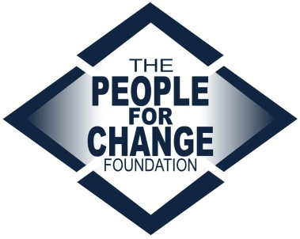

To join MHRSN send an email on mhrsn@pfcmalta.org attaching the following:
- A short cover letter (highlighting your academic work in the area of human rights)
- Your CV
- A passport sized photograph (which will be published on the website)
- A brief profile following the format below (which will be published on the website)
- One to two pieces of writing on, or strongly relating to, a human rights topic (ideally focusing on the Maltese context), which you would be willing to share on the above-mentioned website

PROFILE {this will be published online should you become a member of the Network}
Name | Please provide your full name and surname
Educational background | Please include all degrees and relevant qualifications acquired to date
Publications | Please list any publications (single- or co-authored) on human rights
Areas of interest | For example: migration, children’s rights, disability, human trafficking, indigenous rights, ethnic and racial discrimination, Roma rights,

