Researcher / Research Manager

Application Pack

  - Deadline: March 30th 2020
  - Applications will be reviewed on a rolling basis

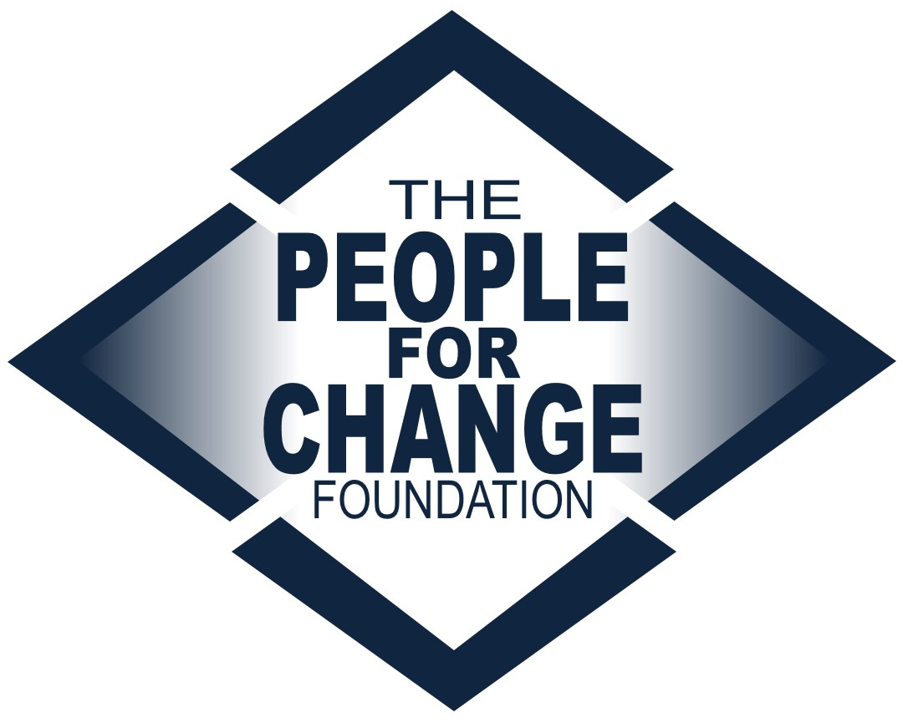

www.pfcmalta.org

About the People for Change Foundation

The People for Change Foundation (PfC) is a Malta-based human rights think tank with a local, European and global scope. Set up in 2007, PfC provides evidence-based, independent, practical and creative ideas on the promotion, respect and protection of human rights in Malta and across the European Union. Our high quality and respected work involves inter-disciplinary analysis, debate and action on a variety of contemporary human rights issues.

PfC was set up with the express aim of contributing to a multilateral process, conducting research in an area of direct relevance to the quality of life and life outcomes of the communities we work with and for; to address international and national legal obligations and development, human rights concerns, and long-term sustainable social cohesion. It also aims to bring together different actors, methods and approaches – activism and research, policy and practice.

The Foundation is Malta’s representative on the FRANET Research Network of the Fundamental Rights Agency and the National Contact Point for the European Website on Integration. We regularly implement projects funded by a number of public and private funders, including the European Commission. We boast a wide disciplinary array of project partners, from across a wide range of sectors – from governments to Universities, from inter-governmental organisations to NGOs and think tanks.
This recruitment takes place at a very exciting time for the organisation as we continue to grow both in terms of the work we undertake as well as the team and network we work with in doing so.

For more information about the organisation and its work visit www.pfcmalta.org

 | About the Position
 | - Job Title |  | Researcher / Research Manager
 | - The Post Holder |  | You will be an exceptional researcher, enthusiastic about looking for and managing data and information. You will have an outstanding ability to develop conceptual notions into pragmatic solutions and recommendations.  You will be organized and able to multitask including working with different people on different pieces of work, yet can work proactively and creatively under pressure and tight deadlines. You can demonstrate a fluent understanding of human rights and policy in Malta and across the European Union particularly in the areas of migration, asylum, racism, aid and youth.  You will be an outgoing and confident individual who is able to represent and promote our mission and objectives. You will be willing to take initiative and work in a team, supervising others to improve outputs and outcomes of the research.
 | - Educational Background |  | Masters degree required, PhD will be considered an asset. Degrees should be in a field related to the role(law, social/political science, etc).
 | - Professional Background |  | 4 years of research experience required, particularly social, policy or legal research. Voluntary work or internships (particularly those linked with human rights issues) will be considered.
 | Skills |  | Whilst seeking a candidate with a particular educational and professional background, we are keen to work with an individual who exhibits a number of important skills:  - Communicative – able to communicate with a range of stakeholders at all levels, including within the organization  - Attentive to detail – able to engage effectively with written work, critically reviewing the quality of outputs and working within a team setting to improve this  - Creative and sensitive – able to develop research questions, translate these into appropriate approaches to asking questions, sometimes to vulnerable groups  - Research tools development – exceptional at developing questionnaires, research designs and research projects more generally  - Innovative – able to identify areas of work where PfC can make a contribution to the policy sphere in Malta and the European Union; helping to expand the work and impact of PfC
 | - Languages |  | Professional level of English, both written and spoken. Knowledge of additional languages, including Maltese, would be considered an asset.
 | - Conflict of Interest |  | Candidates must highlight at application stage any present or potential conflicts of interest, including but not restricted to membership in political parties or work conducted for other organizations in the same sector.
 | - Tasks |  | Research and Analysis (c. 40%)  - Carrying out high quality, in depth research in the field of human rights, particularly migration, racism, youth and development aid  - Developing and implementing methodology and research approaches appropriate to each individual research project  - Designing questionnaires and carrying out interviews as appropriate  - Preparing research results for publication (in a range of formats)  - Working with the Directors and other team members to develop and implement high quality research projects  - Developing background/desk research texts for prospective individual or collaborative funding applications  Research Management and Supervision (c. 40%)  - Coordinating with the Directors, other members of staff, consultants, interns and project partners to plan and implement research timelines and deadlines  - Supporting the project reporting requirements as well as reporting to the Directors on work conducted  - Developing structures in a team setting to facilitate joint working on research projects  - Supervising researchers and research assistants (interns) as they carry out data collection and drafting  - Reviewing research outputs produced by researchers and research assistants  External Communication (c. 10%)  - Speaking and chairing sessions at events and being a public advocate for PfC  - Developing research plans and liaising with partner organisations  - Engaging appropriately and well with practitioners, policy-makers, researchers and others working in the fields of interest to PfC  - Representing the Foundation at meetings and conferences, both in Malta and abroad, as required, including taking minutes for internal circulation and position papers  - Maintaining an on-going relationship with relevant partners in the field  - Writing short texts for social media or press releases about research being conducted and published  - Presenting research findings at PfC events, and as guest speaker at a range of academic and policy events including at EU level  Communication (c. 10%)  Internal communication, particularly with the Directors to give updates, discuss research and agree on priorities.  Any other tasks within and related to the above categories as required from time to time.
 | - Reporting |  | The position holder will report directly to the Directors and will supervise researchers and research assistants (interns). Support in the implementation of tasks will be available through the PfC internship programme and, as appropriate, additional staff members. However the post holder will retain responsibility for the team’s outputs.
 | - Salary |  | Eur 22,000 – 24,000
 | - Conditions |  | Full time  The contract will be for 1-2 years including a 3 month probation period. It is subject to renewal upon agreement by both parties.
 | - Application Requirements |  | Kindly apply by sending the following:  - A cover letter specifically highlighting how you satisfy the requirements of this role;  - A curriculum vitae (incl. a publications list if available  - Two writing samples, which should:  - Reflect the candidate’s research skills (journal articles, policy reports etc.)  - Be of single authorship and written in the past two years  - Demonstrate your analytical skills  - Be published, or kindly provide us with the context for which each one was written
 | - What Happens Next |  | We will review applications on a rolling basis and as they are received, so early application is advised. The final deadline for applications is March 30th 2020. All applications will be acknowledged. Applications that do not contain the required attachments will be considered invalid and will not be considered for the post.  Applications will be assessed on the basis of each candidate’s individual experience, as well as the attachments submitted.  Shortlisted candidates may be invited to complete a task which will last no longer than 1 hour. Following this, shortlisted candidates will be invited to an interview. A second round of interviews may be held if required.  The chosen candidate will be notified as soon as a decision about an offer has been made.  Unfortunately, we are unable to provide individual feedback to candidates who have not been selected.  Should you wish to discuss the role informally, please send us a request by email. Any preliminary conversations will not have any bearing on the selection process.  The tentative start date for the position is May 2020. This can be negotiated for the right candidate.
- Submission |  | Send your application pack to join-us@pfcmalta.org clearly stating the position you are applying for in the subject line.  Any request for information should be sent to directors@pfcmalta.org

