Researcher

Application Pack

  - Deadline: April 10th 2017

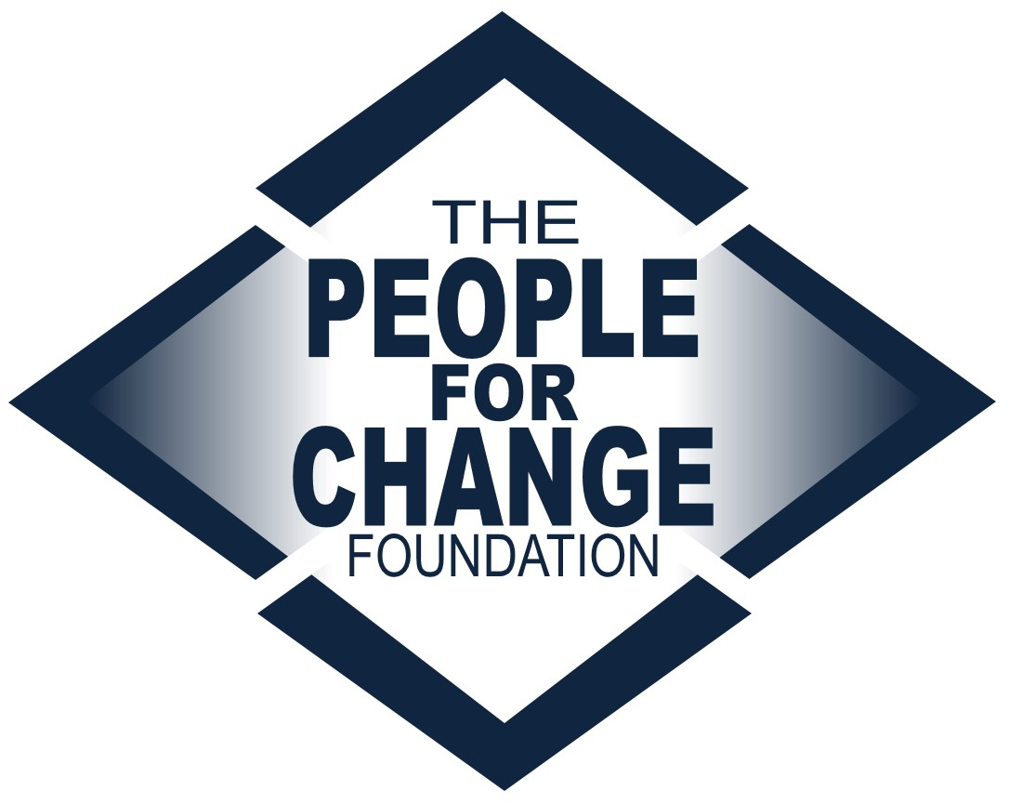

www.pfcmalta.org

About the People for Change Foundation

The People for Change Foundation (PfC) is a Malta-based human rights think tank with a local, European and global scope. Set up in 2007, PfC provides evidence-based, independent, practical and creative ideas on the promotion, respect and protection of human rights in Malta and across the European Union. Our high quality and respected work involves inter-disciplinary analysis, debate and action on a variety of contemporary human rights issues. PfC was set up with the express aim of contributing to a multilateral process, conducting research in an area of direct relevance to the quality of life and life outcomes of the communities we work with and for; to address international and national legal obligations and development, human rights concerns, and long-term sustainable social cohesion. It also aims to bring together different actors, methods and approaches – activism and research, policy and practice.

The Foundation became Malta’s representative member of the European Network Against Racism, and a member of the European Migration Forum and the EASO Consultative Forum. It has run projects funded by a number of public and private funders, including the European Commission. We boast a wide disciplinary array of project partners, including the Malta Ministry of Justice, the National Commission for the Promotion of Equality, the International Organization for Migration, the Universities of Malta, Coventry and Middlesex, UNHCR, IOM, as well as NGOs, think tanks and other organisations from across the European Union.
This recruitment takes place at a very exciting time for the organisation as we continue to grow both in terms of the work we undertake as well as the team and network we work with in doing so.

For more information about the organisation and its work visit www.pfcmalta.org

 | About the Position
 | - Job Title |  | Researcher
 | - The Post Holder |  | You will be an exceptional researcher, enthusiastic about looking for and managing data and information. You will have an outstanding ability to develop conceptual notions into pragmatic solutions and recommendations.  You will be organized yet can work proactively and creatively under pressure and tight deadlines. You can demonstrate a fluent understanding of human rights and policy in Malta and across the European Union particularly in the areas of migration, asylum, racism, aid and youth.  You will be an out-going, confident individual who is able to represent and promote our mission and objectives. You will be willing to take initiative and work in a team, supervising others to improve outputs and outcomes of the research.
 | - Educational Background |  | Masters degree required. Research degree (MPhil, PhD, MRes) preferred. Degrees should be in a related field (law, social science, political science etc).
 | - Professional Background |  | Minimum 2-4 years of research experience required, particularly social or legal research. Voluntary work or internships will be considered.
 | Skills |  | Whilst seeking a candidate with a particular educational and professional background, we are keen to work with an individual who exhibits a number of important skills:  - Creative and sensitive – able to develop research questions, translate these into appropriate approaches to asking questions, sometimes to vulnerable groups  - Attentive to detail – able to engage effectively with written work, critically reviewing the quality of outputs and working within a team setting to improve this  - Communicative – able to communicate with a range of stakeholders at all levels, including within the organization  - Research development – exceptional at developing questionnaires, research designs and research projects more generally  - Innovative – able to identify areas of research where PfC can make a contribution to the policy sphere in Malta and the European Union; helping to expand the work and impact of PfC
 | - Languages |  | Professional level of English, both written and spoken. Knowledge of additional languages, including Maltese and / or French is considered an asset.
 | - Conflict of Interest |  | Candidates must highlight at interview stage any present or potential conflicts of interest, including but not restricted to membership in political parties or work conducted for another organization in the same sector.
 | - Tasks |  | Primary Research and Writing (c. 60%)  - Carrying out high quality, in depth research in the field of human rights, particularly migration, racism, youth and development aid  - Developing methodology and research approaches appropriate to each individual research project  - Designing questionnaires and carrying out interviews as appropriate  - Preparing research results for publication  - Working with the Directors and other team members to develop and implement high quality research projects  - Developing background/desk research texts for prospective individual or collaborative funding applications  Research Coordination (c. 10%)  - Coordinating with project partners, the Directors and interns to plan and implement research timelines and deadlines  - Developing research plans and liaising with partner organisations  - Supporting the project reporting requirements as well as reporting to the Directors on work conducted  Research supervision (c. 15%)  - Developing structures in a team setting to facilitate joint working on research projects  - Supervising interns as they carry out data collection and drafting  - Reviewing research outputs produced by interns and research assistants  Networking (c. 10%)  - Speaking and chairing sessions at high profile events and being a public advocate for PfC  - Engaging appropriately and well with practitioners, policy-makers, researchers and others working in the fields of interest to PfC  - Representing the Foundation at meetings and conferences as required, including taking minutes for internal circulation and position papers  - Maintaining an on-going relationship with relevant research partners in the field  Research Outreach and PR (c. 5%)  - Writing short texts for social media or press releases about research being conducted and published  - Presenting research findings at PfC events, and as guest speaker at a range of academic and policy events including at EU level  Any tasks within the above categories as required from time to time.
 | - Reporting |  | The position holder will report directly to the Directors and will supervise interns and research assistants. Support in the implementation of tasks will be available through the PfC internship programme however the post holder will retain responsibility for the team’s outputs.
 | - Salary |  | Negotiable and commensurate to qualifications and experience.
 | - Conditions |  | Full time  The contract will be for a 1 year period including a 3 month probation period. It is subject to renewal upon agreement by both parties.
 | - Application Requirements |  | Kindly apply by sending the following:  - A completed application form  - Two writing samples, which should:  - Be academic in nature  - Be of single authorship and written in the past three years  - Demonstrate your analytical skills  - Be published, or kindly provide us with the context for which each one was written  - A completed Diversity Monitoring Form  - Submitting a separate CV and/or cover letter is optional
 | - What Happens Next |  | We will review applications as they are received, so early application is advised. The final deadline for applications is April 10th, 2016. All applications will be acknowledged. Applications that do not contain the required attachments will be considered invalid and will not be considered for the post.  Applications will be assessed on the basis of each candidate’s individual experience, as evidenced in the application form, as well as the attachments submitted.  Shortlisted candidates will be invited to complete a task which will last no longer than 1 hour. Following this, the shortlisted candidates will be invited to an interview which will be held at the end of April. A second round of interviews may be held.  The chosen candidate will be notified as soon as a decision about an offer has been made.  Unfortunately, we are unable to provide individual feedback to candidates who have not been selected.  Should you wish to discuss the role informally, please send us any such request by email. However, please note that we are unable to change the deadline, and any preliminary conversations will not have any bearing on the selection process.  The tentative start date for the position is 2nd January 2017. This can be negotiated for the right candidate. Appointment in this position will be subject to provision of a satisfactory police conduct (or international equivalent).
- Submission |  | Send your application pack to join-us@pfcmalta.org clearly stating the position you are applying for in the subject line.

