Office and Projects Coordinator

Application Pack

  - Deadline: Friday 31st March 2017

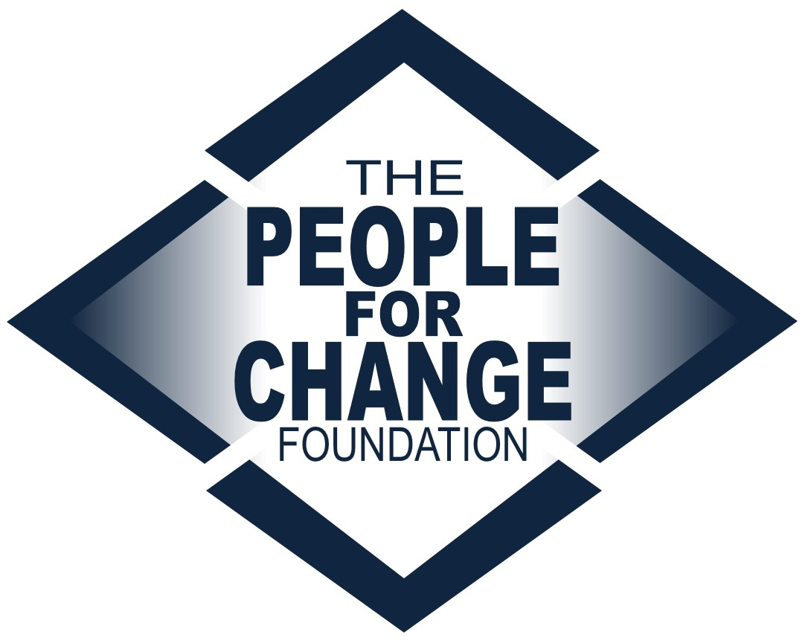

www.pfcmalta.org

About the People for Change Foundation

The People for Change Foundation (PfC) is a Malta-based human rights think tank with a local, European and global scope. Set up in 2007, PfC provides evidence-based, independent, practical and creative ideas on the promotion, respect and protection of human rights in Malta and across the European Union. Our high quality and respected work involves inter-disciplinary analysis, debate and action on a variety of contemporary human rights issues. PfC was set up with the express aim of contributing to a multilateral process, conducting research in an area of direct relevance to the quality of life and life outcomes of the communities we work with and for; to address international and national legal obligations and development, human rights concerns, and long-term sustainable social cohesion. It also aims to bring together different actors, methods and approaches – activism and research, policy and practice.

The Foundation became Malta’s representative member of the European Network Against Racism, and a member of the European Migration Forum and the EASO Consultative Forum. It has run projects funded by a number of public and private funders, including the European Commission. We boast a wide disciplinary array of project partners, including the Malta Ministry of Justice, the National Commission for the Promotion of Equality, the International Organization for Migration, the Universities of Malta, Coventry and Middlesex, UNHCR, IOM, as well as NGOs, think tanks and other organisations from across the European Union.
This recruitment takes place at a very exciting time for the organisation as we continue to grow both in terms of the work we undertake as well as the team and network we work with in doing so.

For more information about the organisation and its work visit www.pfcmalta.org

About the Position

- Job Title | Office and Projects Coordinator
- The Post Holder | You will be an organised, responsible individual with exceptional commitment to the smooth running of the organisation and the team, as well as the various projects and services.  You will be an outgoing, confident individual who is also able to represent and promote the organisation’s mission and objectives. You will be willing to take initiative and work in a team. You will communicate effectively and in a sensitive manner both internally and externally. You will be able to manage multiple things at the same time.
- Educational Background | Bachelors degree or equivalent required.
- Professional Background | At least 2 years working in an administrative or coordination role required, particularly working in a small NGO, business or for government. Experience in a small NGO is considered an asset.  Voluntary work or internships will be considered.
Skills | Whilst seeking a candidate with a particular educational and professional background, we are keen to work with an individual who exhibits a number of important skills:  - Attention to detail – particularly when dealing with finances and reporting  - Strong team player – keen to work with other team members  - Excellent communicator – able to communicate effectively within the team and outside of it  - Problem solver – able to think outside the box and to work proactively  - Independent – able to work independently towards an agreed outcome
- Languages | Strong English language skills required, both written and spoken. Knowledge of additional languages is considered an asset.
- Conflict of Interest | Candidates must highlight at interview stage any present or potential conflicts of interest, including but not restricted to membership in political parties or work conducted for another organization in the same sector.
- Tasks | Team and Office Coordination (c. 45%)  - Coordinating small and internal projects and working horizontally with other team members  - Supporting the organisation’s reporting requirements (including project reporting) as well as reporting to the Directors on work conducted  - Maintaining the office petty cash system and coordinating staff reimbursements  - Ensuring smooth and successful running of the office including the opening and closing procedures, dealing with suppliers etc.  - Coordinating our Asana and Dropbox platforms, the team Facebook group as well as the team calendar  - Coordinating recording of attendance, time sheets and attendance of external events.  - Charing the weekly staff meeting and preparing the meeting report  - Channel external communication to the right team members and coordinating effective internal communication  Human Resource Support (c. 15%)  - Screening internship applications in the first instance  - Managing the internship recruitment, feedback and evaluation process  - Seeking opportunities and avenues for recruitment and internships  - Maintaining the relevant records relating to staff, internships and interest in recruitment positions.  PR and Web Presence (c. 15%)  - Supporting our PR and social media platforms  - Communicating effectively with third parties  - Coordinating our mailing lists  Resource Centres and Projects coordination (c. 20%)  - Coordinating the Daily Human Rights Press Cuttings Service  - Coordinating the development and upkeep of various resource centres hosted by PfC including the Malta Human Rights Library and YouthMetro  - Coordinating non-research projects including Report Racism Malta.  Networking and managing events (c. 5%)  - Organising external and internal events, and PfC representation at external events  - Seeking new funding and partnership opportunities  - Representing the Foundation at meetings and conferences (locally and abroad) as required, including taking minutes for internal circulation and position papers  - Maintaining an on-going relationship with relevant stakeholders in the field  Any tasks within the above categories as required from time to time.
- Reporting | The position holder will report directly to the Directors. Support in the implementation of tasks will be available through the PfC internship programme however the post holder will retain full responsibility for the team’s work.
- Salary | Negotiable and commensurate to qualifications and experience.
- Conditions | Full time, although part time or reduced hours will be considered.  The contract will be for a 1 year period including a 3 month probation period. It is subject to renewal upon agreement by both parties.
- Application Requirements | Kindly apply by sending the following:  - A completed application form  - Two English language writing samples, which should demonstrate your English writing skills. These could be blog posts or opinion pieces.  - A completed Diversity Monitoring Form  - Submitting a separate CV and/or cover letter is optional
- What Happens Next | We will review applications as they are received, so early application is advised. The final deadline for applications is March 31st 2017. All applications will be acknowledged. Applications that do not contain the required attachments will be considered invalid and will not be considered for the post.  Applications will be assessed on the basis of each candidate’s individual experience, as evidenced in the application form, as well as the attachments submitted.  Shortlisted candidates will be invited to complete a task which will last no longer than 3 hours. Following this, the shortlisted candidates will be invited to an interview which will be held in the first week of April. A second round of interviews may be held if necessary.  The chosen candidate will be notified as soon as a decision about an offer has been made.  Unfortunately, we are unable to provide individual feedback to candidates who have not been selected.  Should you wish to discuss the role informally, please send us any such request by email. However, please note that we are unable to change the application deadline, and any preliminary conversations will not have any bearing on the selection process.  We would like the selected candidate to start in the position as soon as possible after the selection is made and ideally by 20 April 2017.. This can be negotiated for the right candidate.
- Submission | Send your application pack to join-us@pfcmalta.org clearly stating the position you are applying for in the subject line.

